**User Research Methods**

1. **Surveys**:

We have curated 8-10 questions regarding the design and experience of various applications.

The link to Questionnaire and responses: <https://forms.gle/Pkp5TgiTPNUJJdxN6>

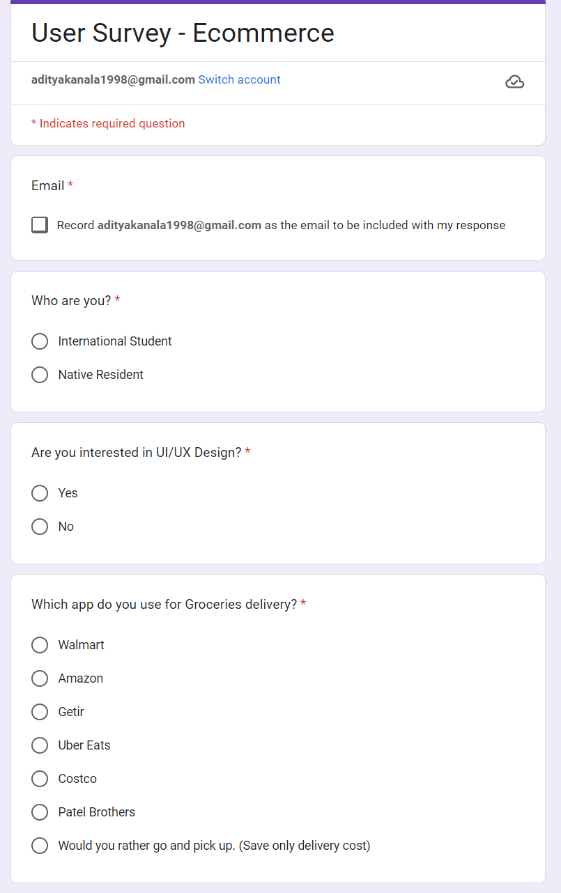 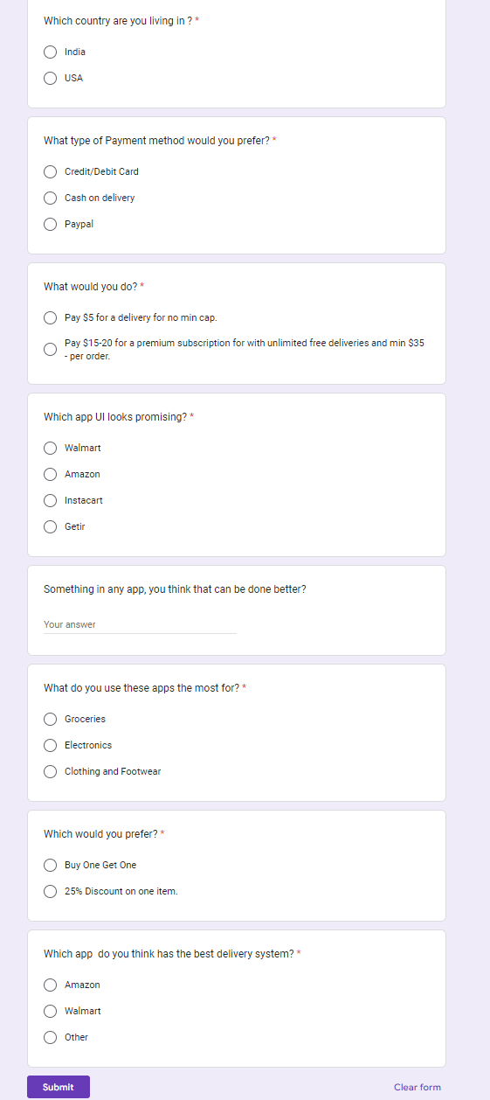

Below are the questions and the analysis of the responses recorded in a pie chart that were asked to the users:

1. Chart, pie chart

   Description automatically generatedWhich application would you use for Groceries Delivery?
2. What Payment method would you use the most?

1. Which Application UI they liked the most?

1. Which payment method would they use the most?

1. A Question regarding Discounts and Coupons?

1. A Question regarding the Delivery System?

1. What do they look the most for in our application?

1. **Stakeholder Interviews:**

For the project research we have interviewed the a few stakeholders i.e., the users, with a few frequent questions that would help us get the users perspective and needs.

We have divided the stakeholders into 2 groups of 3 stakeholders each.

We have cumulated the responses of the stakeholder groups for each question as show below.

1. **What motivated you to download and start using the app?**
   1. **Answers:** 
      1. Mohit: I heard about it from a friend after coming to the US and wanted to use it for regular needs.
      2. Prakhya: I needed one app to find all my needs at a low price
      3. Swaroop: It was suggested by many of my seniors, so I started using it.
2. **What are some of the app's most valuable features to you?**
   1. **Answers:** 
      1. Mahith: The reminder feature about the subscription due date and regular orders.
      2. Nirav: The easy checkout option.
      3. Shubham: The search functionality
3. **Have you tried using any other similar apps? How does this one compare?**
   1. **Answers:** 
      1. Mohit: Yes, I do use target and Costco. But this is more user friendly
      2. Prakhya: The others had a little more attractive UI compared to this
      3. Swaroop: Yes, customer service is the standout for me.
4. **What are some of the app's biggest shortcomings or areas for improvement?**
   1. **Answers:** 
      1. Mahith: Navigation for the new users.
      2. Nirav: The items are out of stock frequently.
      3. Shubham: Need for more customization
5. **Are there any changes to the app's design or user interface that you would suggest?**
   1. **Answers:**
      1. Mohit: The UI is very plain and simple.
      2. Prakhya: A more colorful and playful UI might attract more people.
      3. Swaroop: Not much.
6. **How frequently do you use the app?**
   1. **Answers:** 
      1. Mahith: I use the app multiple times a day, every day
      2. Nirav: I only use the app occasionally when I need to accomplish a specific task
      3. Shubham: I used to use the app frequently, but I have found other alternatives and now only use them parallel to
7. **Would you recommend this app to others? Why or why not?**
   1. **Answers:**
      1. Mohit: Absolutely, the app has been beneficial for me
      2. Swaroop: I would not recommend the app to others because I have had too many frustrating experiences with it
      3. Prakhya: I would only recommend the app to others who have specific needs that it meets well
8. **Are there any features you would like to see added to the app?**
   1. **Answers:**
      1. Mahith: Not much as of now.
      2. Nirav: No, it serves my needs now.
      3. Shubham: No
9. **FAQs Reviews and UX research for Walmart mobile app**

* **Methodology:** On Research, we found an online survey of 10 Walmart website and mobile app users. The survey was conducted in April 2023 and targeted users who had made a purchase on the site or app in the past six months. The survey consisted of multiple-choice questions and open-ended questions.
* **Most Common Questions:** Based on the survey results, the most frequent questions users have about navigated Walmart's website or mobile app are related to finding products (54%), checking product availability (32%), and placing orders (24%). Other frequent questions include tracking orders (18%), accessing customer support (14%), and payment methods (11%).
* **Features or Functions Users Struggle to Find or Use:** Approximately 40% of users surveyed reported having difficulty finding specific products on Walmart's site or app, while 22% had difficulty adding products to their cart, and 16% had difficulty navigating the checkout process. Additionally, 12% of users reported having trouble accessing their account information, and 9% had difficulty using the site or app's search function.
* **Questions about Specific Products or Categories:** Around 48% of users reported having questions about specific products or product categories on Walmart's site or app. The most common product categories users had questions about were electronics (28%), home appliances (22%), and clothing (19%). Users mostly want to know more about the features or specifications of a particular product (42%), followed by the pricing and discounts offered (31%) and the availability of a specific item at a particular store (27%).
* **Product Search and Search Results**: Most of the users (80%) reported searching for products on Walmart's site or app by typing in keywords or phrases in the search bar. Additionally, 16% of users reported browsing products by category or department. Overall, 78% of users reported being satisfied with the search results provided by Walmart's site or app. However, 22% of users reported finding it difficult to filter or sort search results to find the exact product they were looking for.
* **Accessing Information about Walmart's Policies**: Most users (92%) reported being able to easily access information about Walmart's policies, such as shipping and returns, by visiting the site or app's customer service or by clicking on the relevant links located at the bottom of the page. Additionally, 8% of users reported having difficulty accessing this information.